**Accounting:**

**1.Accounting Configuration**

**Fiscal Location 🡪 Package: EG Egypt**

**Taxes**

Default Tax

Configure Tax accounts as of Kemet CoA

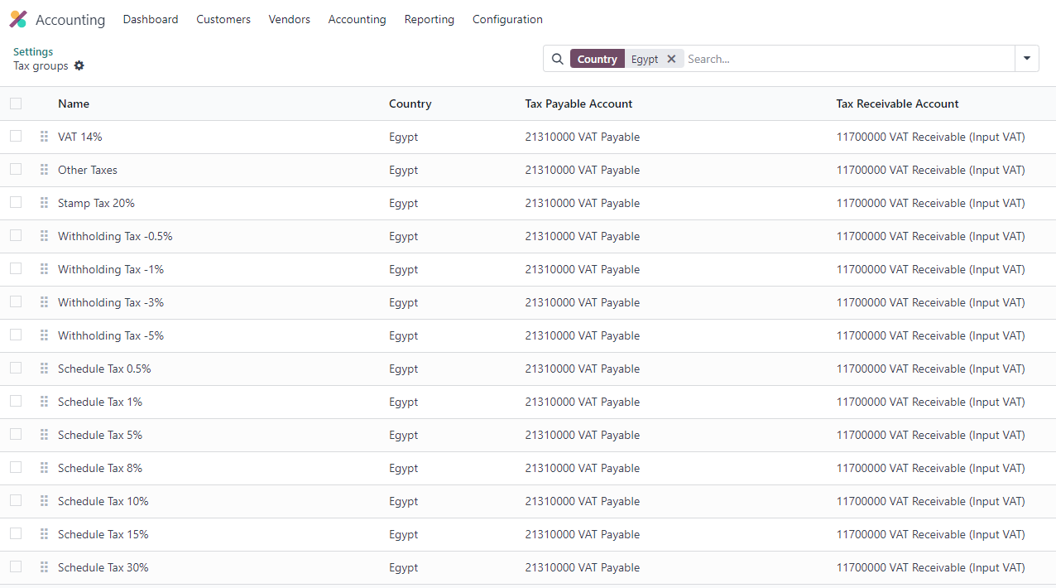

Fiscal Country: Egypt

Customer Invoice 🡪 Taxes in company currency

**Currency EGP**

Multiy Currencies:

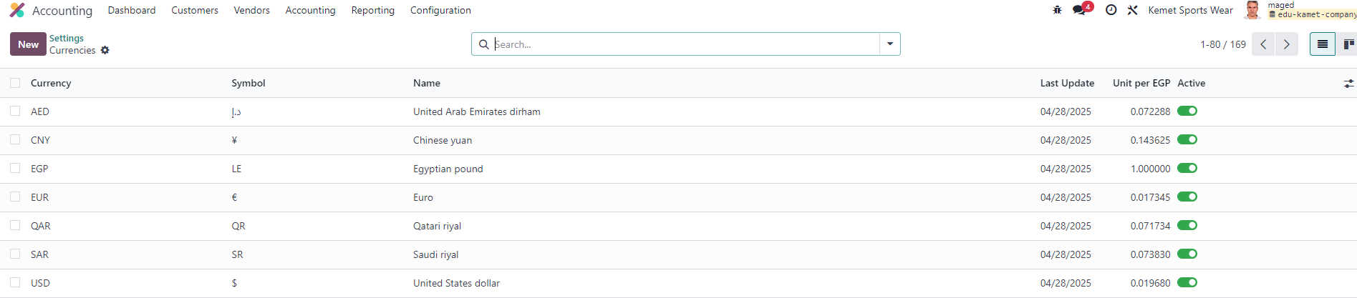

Automatic Currency Rates 🡪 Update exchange rates automatically

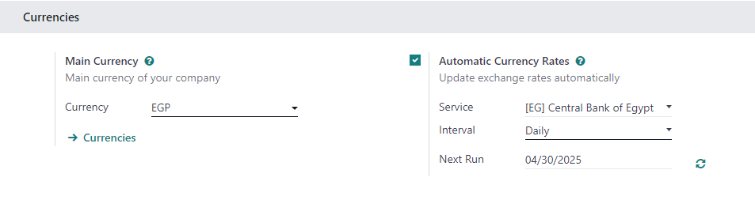

Units of Measure

Vendor Bills 🡪 Auto-validate bills

**Default Accounts**

Adjusting Default Accounts with Kemet CoA ‘ s Accounts

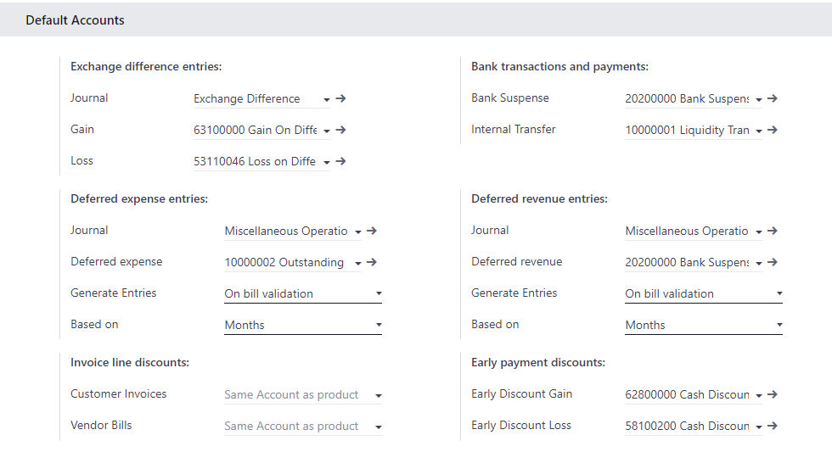

**Stock Valuation**

Automatic Accounting 🡪 Enable automatic accounting entries for stock movements

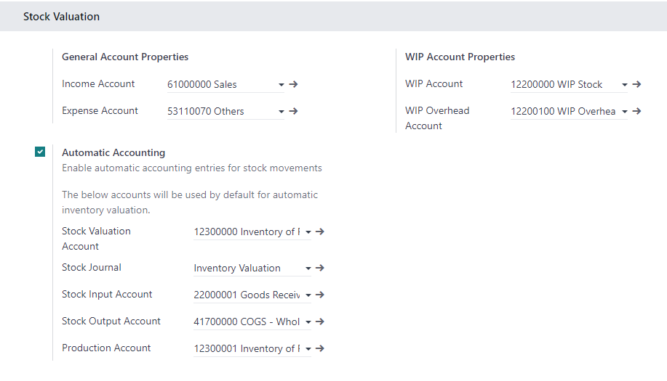

**Fiscal Periods**

Fiscal Year 🡪 Last Day: December 31

Dynamic Reports 🡪 Navigate easily through reports and see what is behind the numbers

**Analytics**

Analytic Accounting 🡪 Track costs & revenues by project, department, etc

Budget Management 🡪 Use budgets to compare actual with expected revenues and costs

**Chart od Accounts**

By Odoo CoA Account Type:

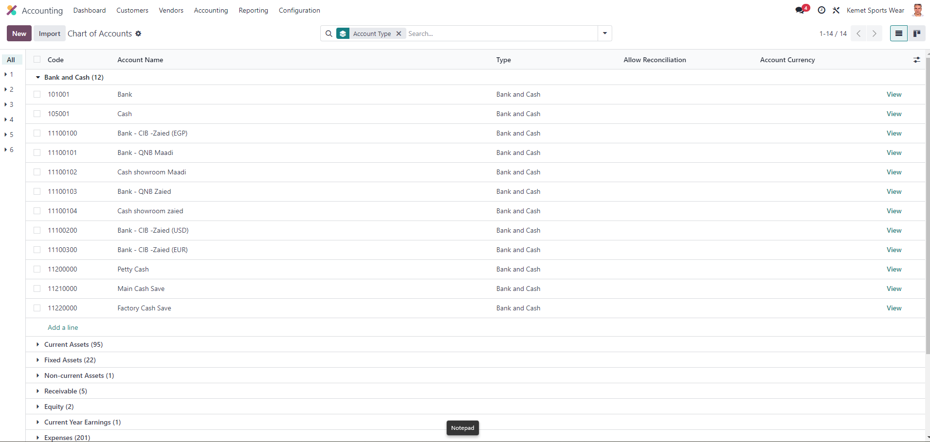

**Assets**

**Assets and Depreciations: Process in Odoo**

1. Create Vendor Bill to purchase the Fixed – Assets – Machines

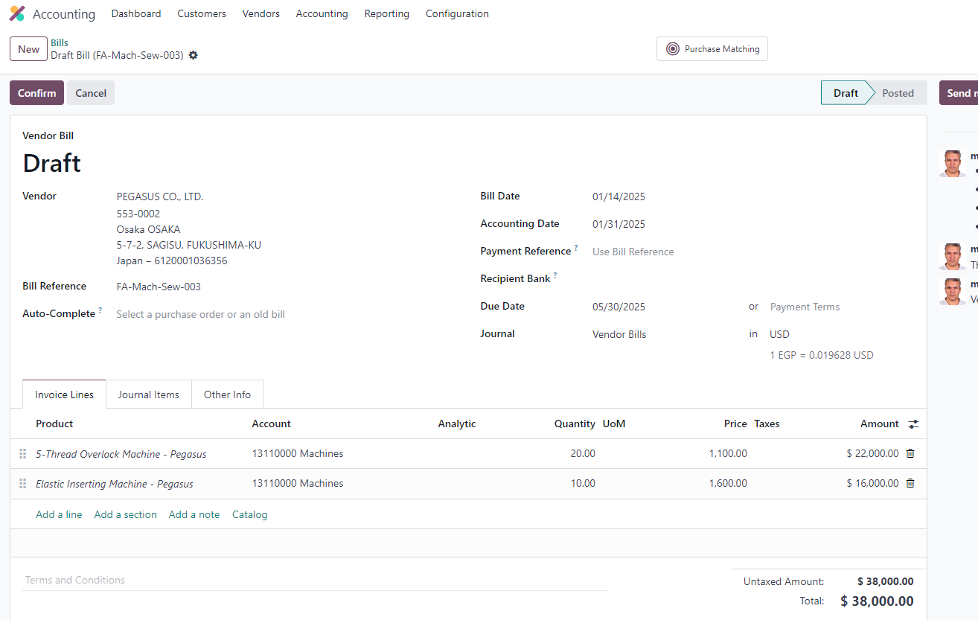

1. Adding Vendor Details, Payment Term, Supplier Currency, Fiscal Position

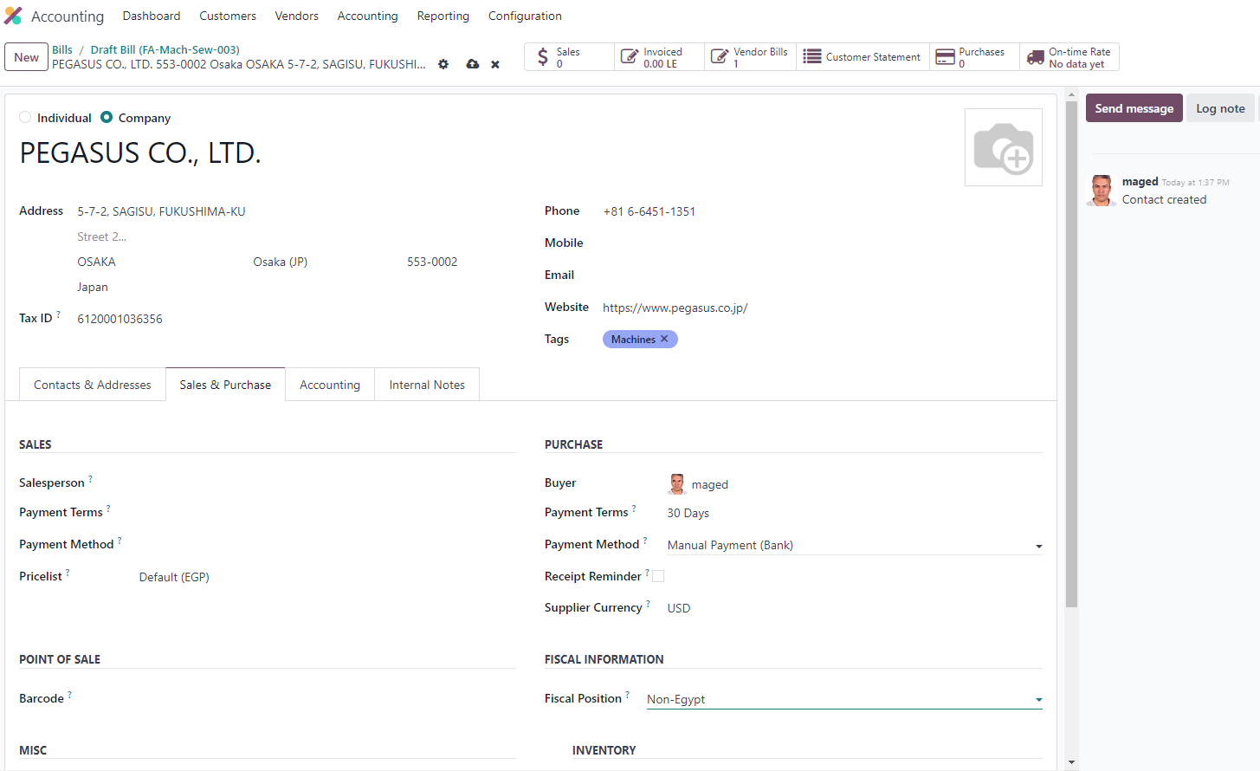

1. Journal Indicate Fixed Assets -Machine debet , and Payable – Suupler Credit

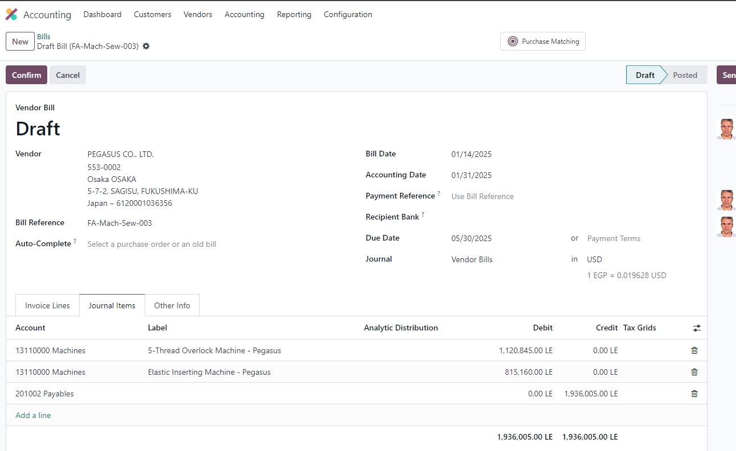

1. Asstes “Samrt Button” indicate the Qty 30 Machines has beend added to Assets – Assets Model Machine and depreciation calculated automaticly

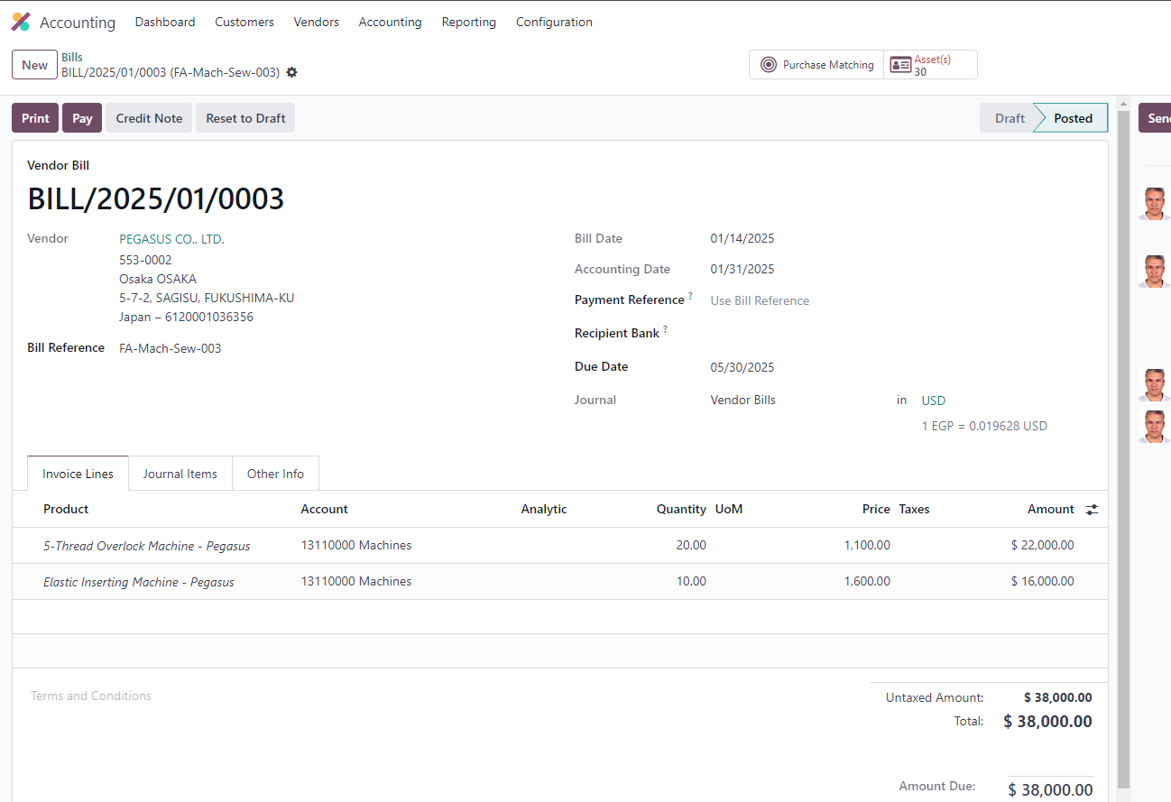

1. Click the Asset(s) Smart button will show each machine as an asset with its Asset Model and Depreciation Methods

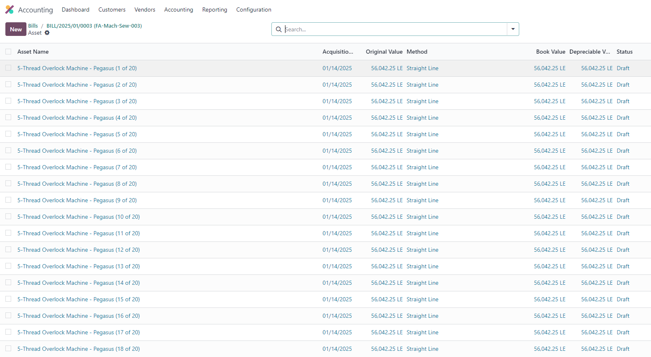

1. Click on the 1st machine will open the assets model – machine related to this asset automtaicly

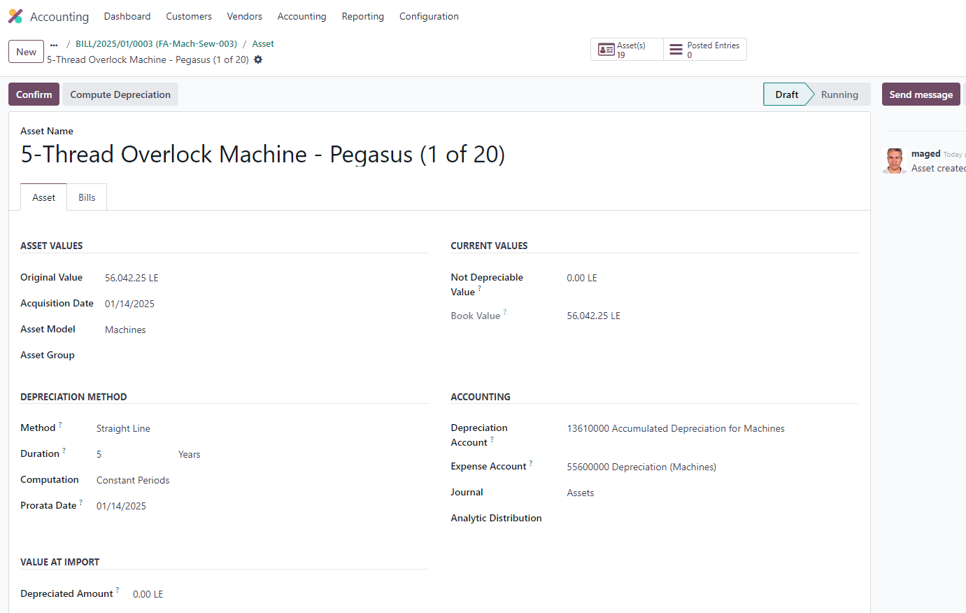

1. Click confirm to auto calculate the asset depreciation effective from Accuistation Date

Which is same as Vendor Bill date



1. Depreciation board of asset – machine

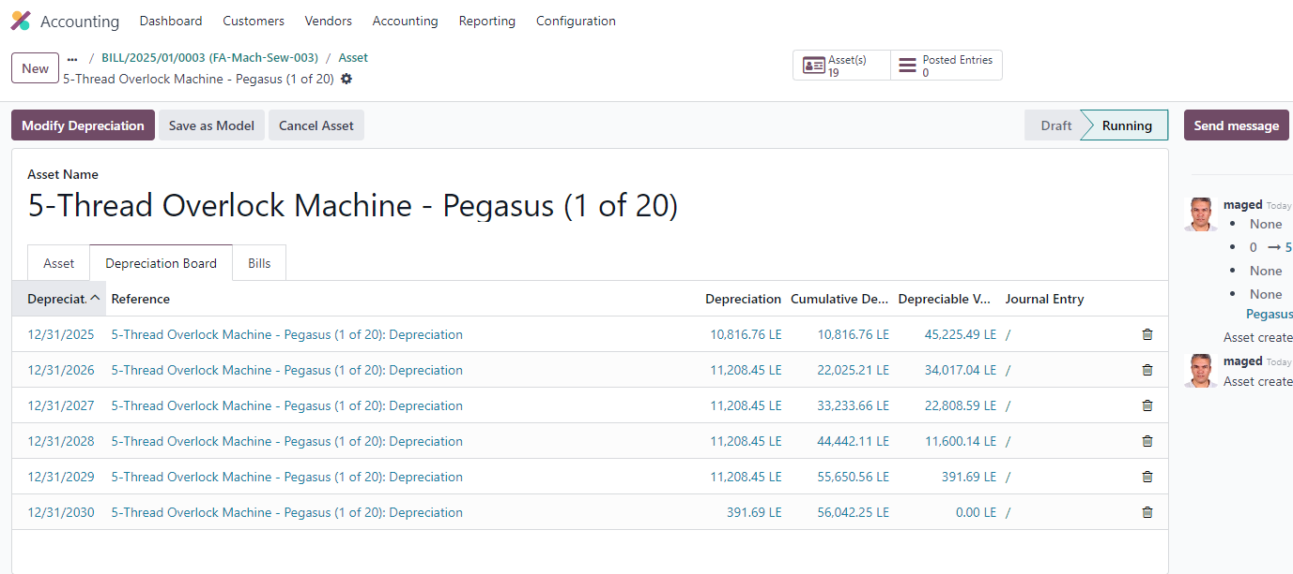

9 - The Vendor bill created via accounting module has been linked and show in Bills tab

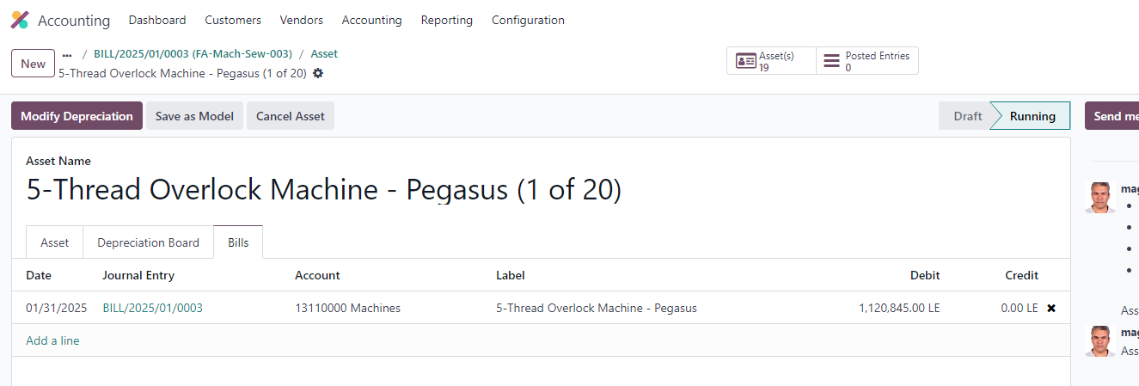

**Pro Sync integrated Solutions** **Kemet Sportswear Co.**

**Project Manager** **Project Manager**

Mr. Maged Kamel MR. Atef Ibrahim